Objective Questions

- Does any table have missing values or duplicates? If yes, how would you handle it?
Yes, there were missing values in the dataset Eg:-
- 49 company, 29 state, 47 fax values are null in the customer table.
- 1 reports_to value is null in the employee table.
- 978 composer values are null in the track table.
But there are no duplicate values in the whole dataset.
Also, in case of null values we can use COALESCE function

- Find the top-selling tracks and top artist in the USA and identify their most famous genres.
SQL query:
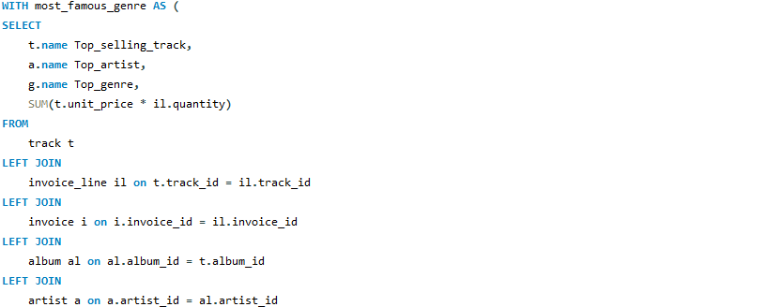
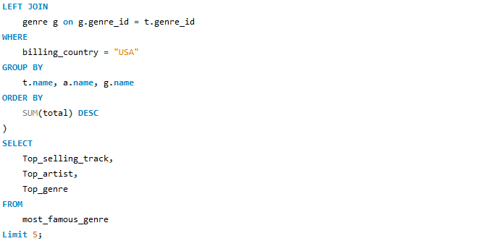
Output :
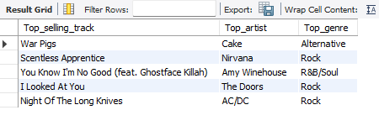
- Top Selling - War Pigs
- Top Artist - Cake
- Most Famous Genre - Rock

- What is the customer demographic breakdown (age, gender, location) of Chinook's customer base?
SQL query:
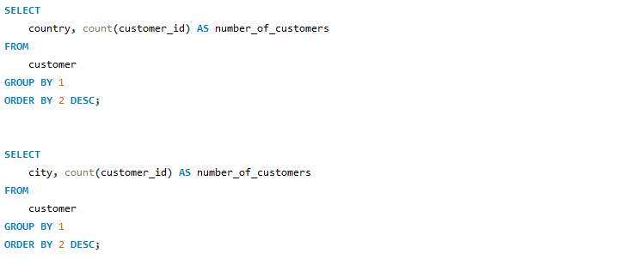

Output :
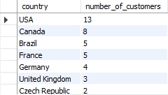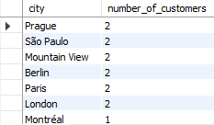

- Location:-
  - The customer base of Chinook is diverse, covering 24 countries.
  - The majority of customers are from the USA.

- Note:-
- The Customer table does not include columns for age or gender, making it difficult to analyze customer demographics further.

- Calculate the total revenue and number of invoices for each country, state, and city:
SQL query:
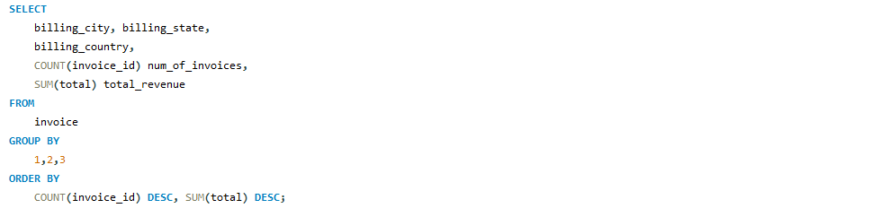
Output :
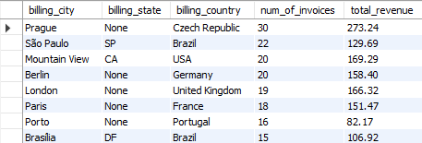

- Find the top 5 customers by total revenue in each country
SQL query:
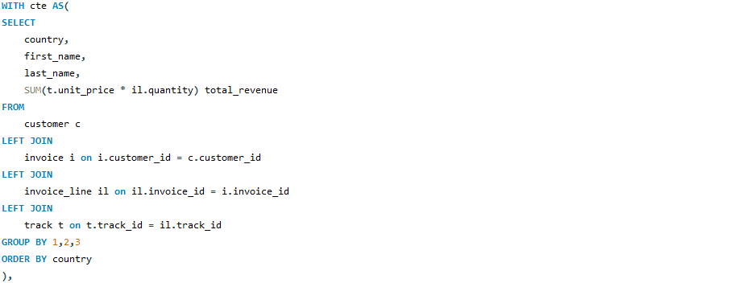
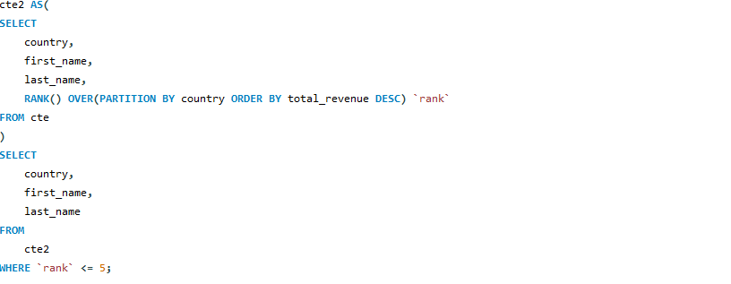
Output :
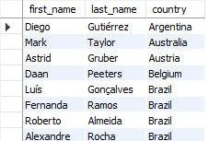

- Identify the top-selling track for each customer
SQL query:
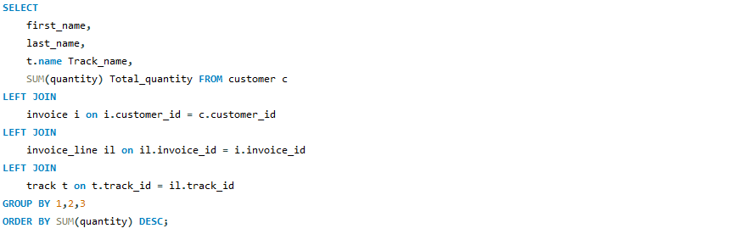
Output :
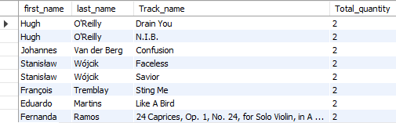

- The customers had a comparable number of different tracks.
- The similarity in the quantity of tracks made it difficult to determine the best one for each customer.
- As a result, selecting a top track for each customer became challenging.

- Are there any patterns or trends in customer purchasing behaviour (e.g., frequency of purchases, preferred payment methods, average order value)?

SQL query:
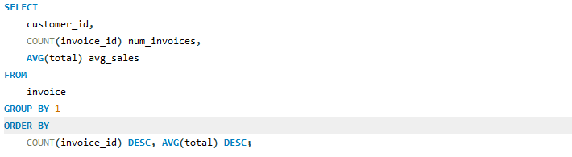
Output :
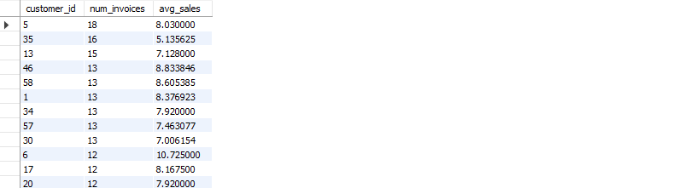
- There is no correlation or trend between the number of orders placed by different customers and their average sales.
- The average sales are likely influenced by the unit price of each track, rather than the frequency of orders.
- The number of orders does not appear to be a determining factor for average sales.

- What is the customer churn rate?
SQL query:
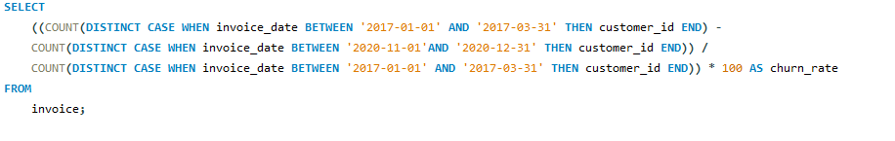
Output :
The customer churn rate of the company is 32.432 based on the total number of customer
(Customer churn rate is defined as the percentage of customers who stop doing business with an organization over a period of time.)
Note -
- I have taken the assumption that the total number of customers in the beginning is equal to the customers joining in the first 3 months.
- I have taken the assumption that the churn rate will be calculated on the basis of the number of customers left in the last two months.

- Calculate the percentage of total sales contributed by each genre in the USA and identify the best-selling genres and artists.
SQL query:
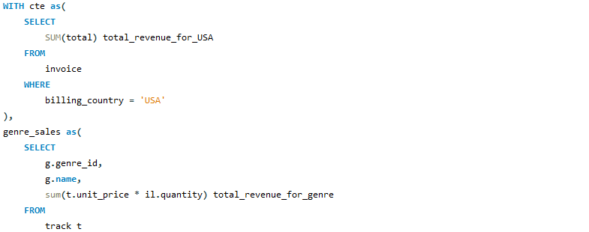
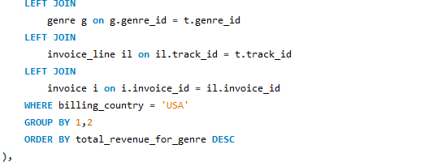
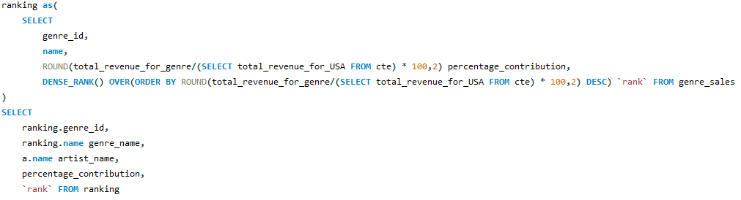

Output :
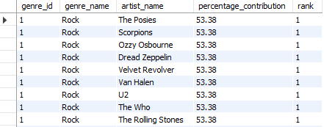
- The top-selling genre in the USA is Rock.
- Following artists are all associated with the Rock genre
- The Posies, Scorpions, Ozzy Osbourne, Dread Zeppelin, Velvet Revolver, Van Halen, U2, The Who, The Rolling Stones, The Police, The Doors, The Cult, Terry Bozzio, Tony Levin & Steve Stevens

- Find customers who have purchased tracks from at least 3 different genres
SQL query:
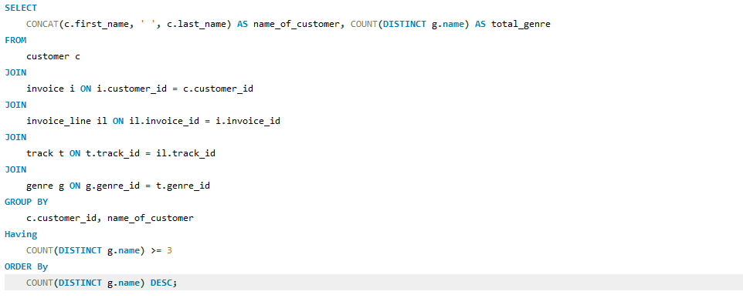
Output :
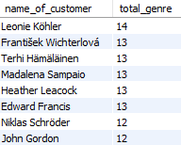
Leonie Köhler is the person who has bought tracks from 14 different genres.
- Rank genres based on their sales performance in the USA
SQL query:
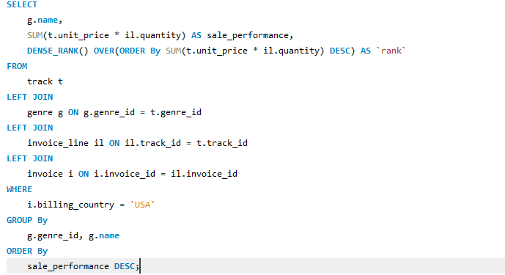
Output :
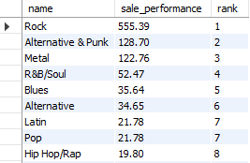
- Identify customers who have not made a purchase in the last 3 months
SQL query:
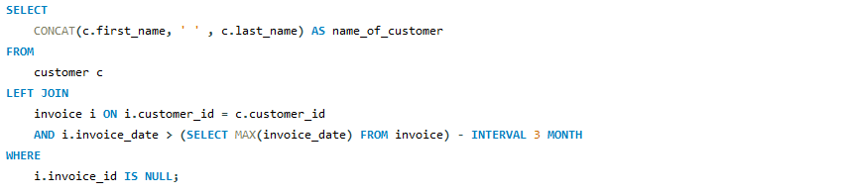
Output :
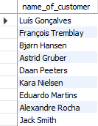

Subjective Questions
1.Recommend the three albums from the new record label that should be prioritised for advertising and promotion in the USA based on genre sales analysis.
Reference: SQL query - Subjective Questions - Answer 1
SQL query:
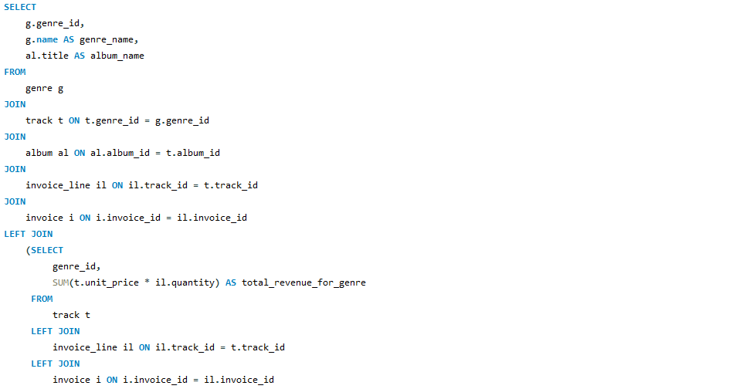
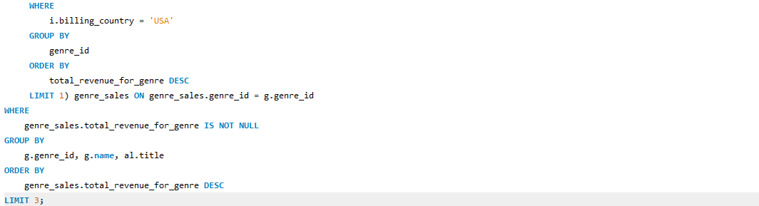
Output :
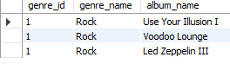
Recommendation: - The top 3 albums to prioritize for advertisements and promotions in the USA, based on genre analysis, are:
• Use Your illusion 1
• Voodoo Lounge
• Led Zeppelin 3
All these albums are from the genre ROCK as it is the most popular genre in the USA.

2.Determine the top-selling genres in countries other than the USA and identify any commonalities or differences.
SQL query:
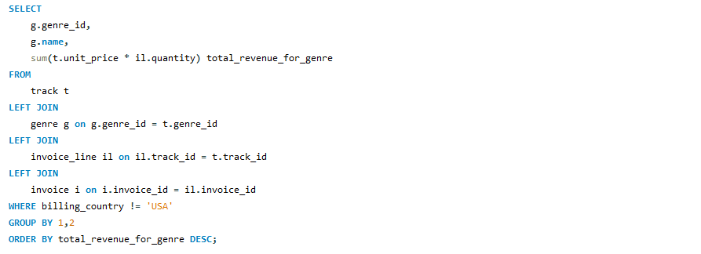
Output :
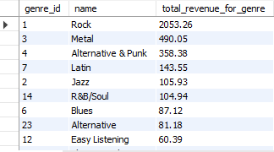
The commonality between the data for the USA and the rest of the world is that the ROCK genre holds the top spot in both. The second and third spots are occupied by the METAL and ALTERNATIVE & PUNK genres, respectively.
3.Customer Purchasing Behavior Analysis: How do the purchasing habits (frequency, basket size, spending amount) of long-term customers differ from those of new customers? What insights can these patterns provide about customer loyalty and retention strategies?
SQL query:
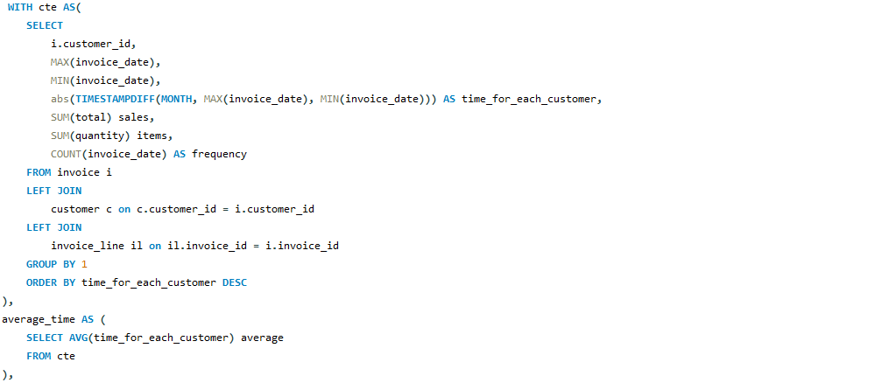
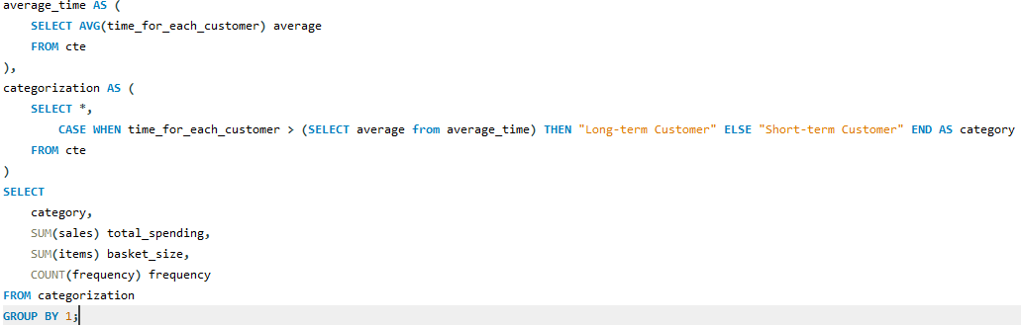
Output :
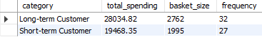
Visualization :
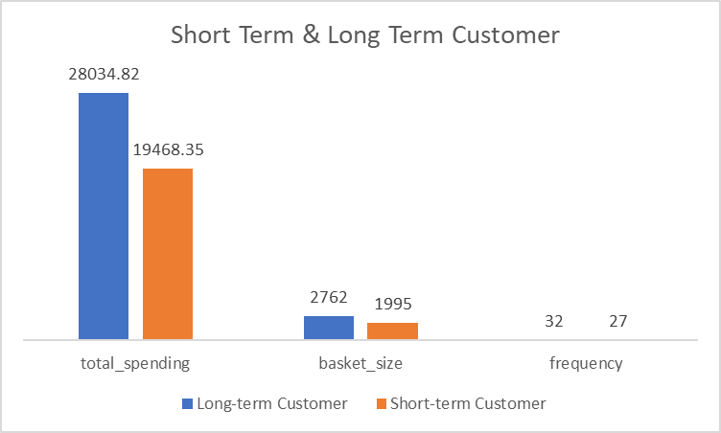
Insights:
The spending amount, basket size, and purchase frequency are higher for long-term customers compared to short-term customers.
Recommendations:
- Customer loyalty significantly contributes to increasing company revenue, as long-term customers tend to make more purchases than short-term customers.
- Therefore, the company should focus on improving customer retention rates to drive sustained sales growth over time.

4.Product Affinity Analysis: Which music genres, artists, or albums are frequently purchased together by customers? How can this information guide product recommendations and cross-selling initiatives?
SQL query:


Output :
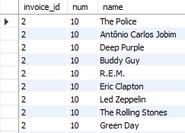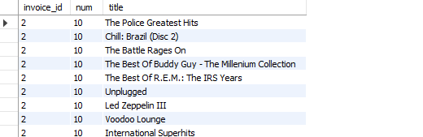
- When the output of the above query is plotted as a table in Excel and a pivot table is created with genres in rows, invoice IDs in columns, and the count of genres in values, it is observed that the Rock, Metal & Alternative, and Punk genres are frequently purchased together.
- Similarly, when analyzing albums, it can be seen that Mezmerize, The Doors, and Dark Side of the Moon are frequently purchased together.
- In the same way, when analyzing artists, Green Day, Foo Fighters, and U2 are the artists most frequently purchased together.

5.Regional Market Analysis: Do customer purchasing behaviors and churn rates vary across different geographic regions or store locations? How might these correlate with local demographic or economic factors?
SQL query:
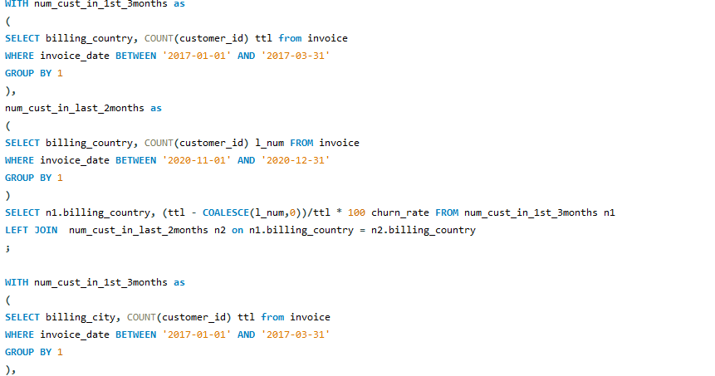
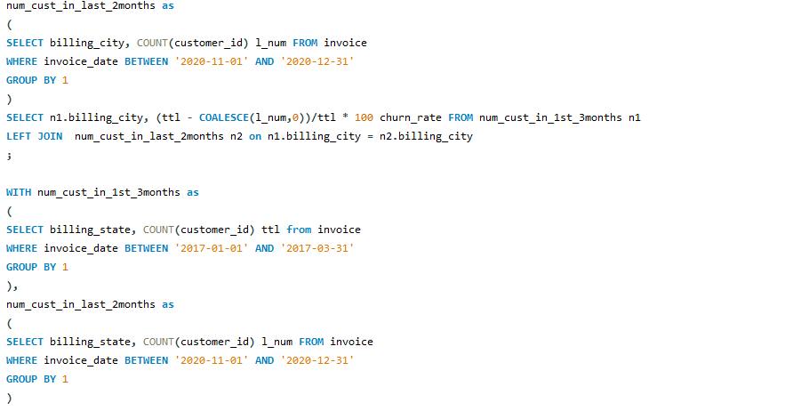
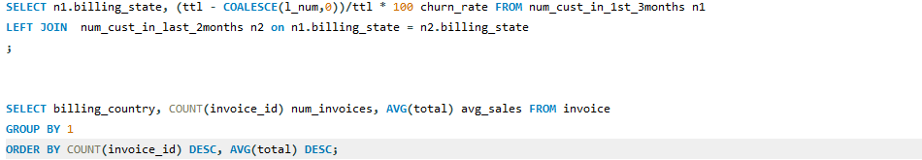
Output :
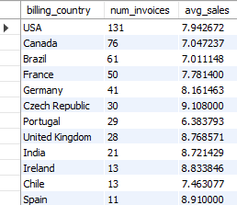
Visualization :
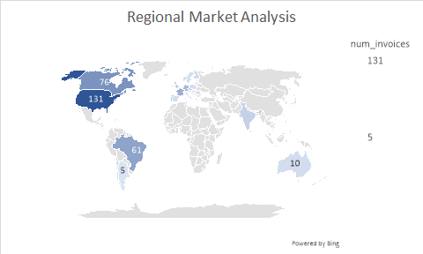
- Insights:
- The customer churn rate varies across different countries, cities, and states, as seen from the above queries.
- European countries exhibit a higher churn rate compared to other regions.
- The purchasing behavior of customers also differs across various countries.

Recommendations:
Developed nations have a higher number of orders and average sales compared to developing nations. This indicates that economic factors play a significant role in the sales generated from a region.

Therefore, more advertisements should be targeted in countries with strong economies, while offering lower-priced tracks in countries with weaker economies. The population of countries can also be considered a key metric in analyzing customer behavior and sales performance.

6.Customer Risk Profiling: Based on customer profiles (age, gender, location, purchase history), which customer segments are more likely to churn or pose a higher risk of reduced spending? What factors contribute to this risk?
SQL query:
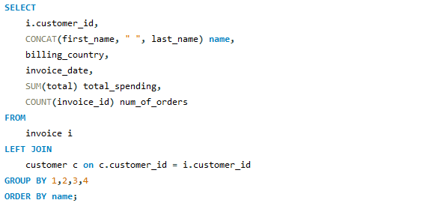
Output :

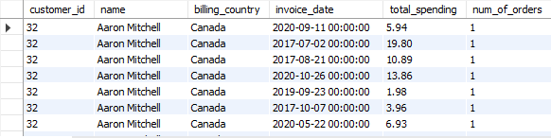

Visualization :
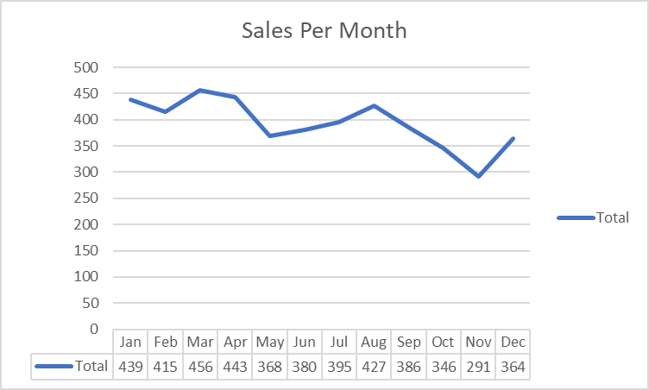
After analyzing the data through charts and tables, it is evident that countries with already high spending amounts and order frequencies are seeing an increase, while sales and order frequency remain stagnant in other countries. Therefore, it is clear that new promotional campaigns are needed in these countries to reduce churn rates and sustain or increase spending.

Factors which contribute to this risk are:
- Are younger customers more prone to churn? (If data is available)
- Does gender influence churn rates? (If data is available)
- What is the impact of location on churn rates?
- How does spending behavior differ between frequent and infrequent buyers?
If information regarding the age and gender of the customers was available, the customer segmentation would have been as follows:
Young Male - High Spenders
Young Female - High Spenders
Old Male - Low Spenders
Old Female - Low Spenders

7.Customer Lifetime Value Modelling: How can you leverage customer data (tenure, purchase history, engagement) to predict the lifetime value of different customer segments? This could inform targeted marketing and loyalty program strategies. Can you observe any common characteristics or purchase patterns among customers who have stopped purchasing?
- To predict customer Lifetime Value
It's important to analyze key factors such as customer tenure and their purchase history
- High-Value Customers:
  - Long tenure and frequent, high-value purchases.
- Low-Value Customers:
  - Short tenure and limited purchasing history.
This segment will help us to identify customers with high revenue potential for targeted marketing and retention strategies.

- Targeting Potential Loyal Customers.
- For customers with a short tenure but significant purchase history, promotional campaigns should be specifically targeted at this group.
- Focus on personalized offers or loyalty programs to convert them into long-term customers.
- Early identification and nurturing can increase customer retention and Lifetime value

- Economic Factors and Customer Churn:
- A common characteristic among customers who have stopped purchasing is that they predominantly belong to underdeveloped or developing countries
- This suggests that economic factors, such as lower disposable income or limited access to purchasing power, play a significant role in customer churn.
- Targeted promotional strategies, such as discounts and localized advertising, can help reduce churn.
- Using social media and online channels can improve engagement in economically weaker regions.

8.If data on promotional campaigns (discounts, events, email marketing) is available, how could you measure their impact on customer acquisition, retention, and overall sales?
If the data on promotional campaigns was available, I would have used it to analyze its impact on
1. Customer Acquisition:
- Analyzing the growth in customer numbers over time.
- Tracking participation rates in events held across various locations.
- Measuring the increase in click-through rates resulting from email marketing campaigns.
2. Customer Retention:
- Monitoring the number of long-term customers returning to events and making purchases after a gap.
- Assessing the impact of discounts on customer retention and repeat purchases.
3. Sales Performance:
- Evaluating the increase in sales driven by promotional campaigns.
- Identifying trends to determine which promotional campaigns were the most effective.
- Analyzing the acquisition of new customers through discount-driven sales.

9.How would you approach this problem, if the objective and subjective questions weren't given?
If the objective and subjective questions weren't provided, I would still approach the problem by following the steps are as follows:
1. Data Exploration and Cleaning
- Identify Missing Values and Duplicates
- Assess Data Structure
2. Customer Segmentation
- Customer Demographics Analysis
- Customer Behavior and Trends
3. Sales Analysis
- Revenue and Invoices per Region
- Top-Selling Tracks and Artists
- Genre Sales Analysis
- Track and Genre Association
4. Customer Retention and Churn
- Churn Rate Calculation
- Long-term vs. New Customers
5. Regional and Market Insights
- Regional Market Analysis
- Product Affinity Analysis
6. Predictive Modeling
- Customer Lifetime Value Prediction
- Risk Profiling
7. Promotional Campaign Effectiveness
8. Strategic Recommendations
- Targeted Marketing Campaigns
- Loyalty Programs
- Promotions and Discounts
Conclusion:
By following these steps, I would be able to uncover key insights from the music sales data, identify customer trends, and provide data-driven recommendations to help Chinook enhance its strategy in the physical music market.

10.How can you alter the "Albums" table to add a new column named "ReleaseYear" of type INTEGER to store the release year of each album?
Query :
We can use the ALTER TABLE command to add a new column to the Album table.
Code: -
ALTER TABLE album
ADD ReleaseYear
data_type int;

11.Chinook is interested in understanding the purchasing behavior of customers based on their geographical location. They want to know the average total amount spent by customers from each country, along with the number of customers and the average number of tracks purchased per customer. Write an SQL query to provide this information.
SQL query:
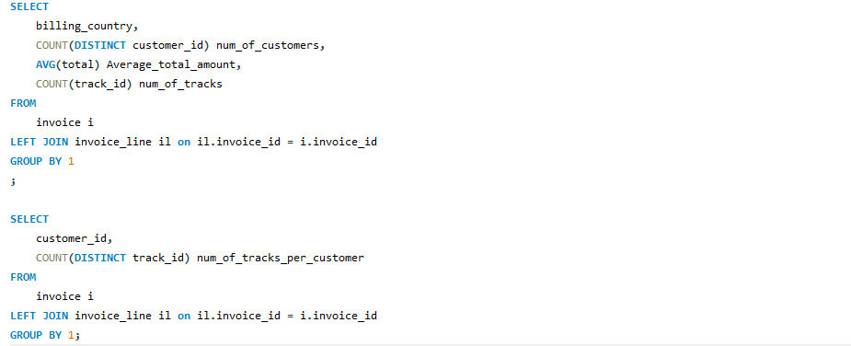

Output :
